Frazier Employee
-
Time Tracker

updated on 08/13/2008 by ken tennant
Welcome!

This is the training manual for the Frazier Employee Time Tracker system. The intent of this training manual is to give instructions on how to use the system. I have included pictures to help with the written explanation of the system.

If there are any errors or suggestions on making this manual better, please contact me using the following information below:

Kenneth D Tennant
1547 Agate Drive
Pocatello Id 83202
(208) 637-1813
kstennant@cableone.net

Overview Error! Bookmark not defined.
The Intent Error! Bookmark not defined.
The Employee Profile Error! Bookmark not defined.
The Manager Profile Error! Bookmark not defined.
Login Error! Bookmark not defined.
Main Page Error! Bookmark not defined.
The Week Error! Bookmark not defined.
Employees Error! Bookmark not defined.
Projects Error! Bookmark not defined.
Missed Punch Error! Bookmark not defined.
Assignment Error! Bookmark not defined.
Employee Error! Bookmark not defined.
Add Entry Error! Bookmark not defined.
Conclusion Error! Bookmark not defined.

Overview

The Intent
This website provides an electronic web-based system customized to achieve two goals.

- Capture the daily time punches for an employee
- Track the time spent by the employee on system registered projects

To achieve both of these goals, the system uses two different profile types.

The Employee Profile
The employee profile has basic access to perform the following actions:

- Record daily activity using the main screen (See Page 6)
- View past weeks of punch activity (See Page 8)
- Add missed punches for previous days (See Page 11 or 14)

The employee will punch in and out for each project that they work on for the day.

The Manager Profile
This manager profile has advanced access to perform the following actions in addition to the activities stated for the employee profile:

- Add and maintain employees to the system (See Page 9)
- Retrieve a weekly report activity done for a selected week (See Page 10)
- Fix missed punches or recorded punches of employees (See Page 11 or 14)
- Add and maintain projects to the system (See Page 10)
- Change project assignments (See Page 12)

The rest of the manual will cover each of the screens existing for the website to show it achieves the two goals outlined above.
Login
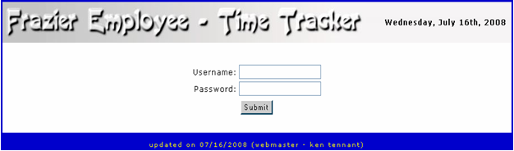
fig 1.0

To use the system, the user will need to register with Shauna Evans in Salt Lake City. The user can reach her at (801) 268-2016. She will provide the user a username and password with the assigned profile types.

When the user receives this information, use the username and password in the form shown in figure 1.0 with the corresponding fields and click on the ‘Submit’ button to log into the system.

Main Page
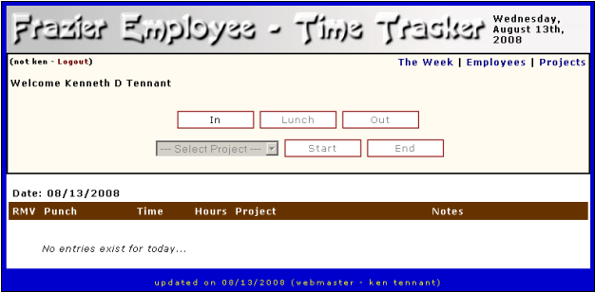fig 2.0

The main page gives the user the ability to record the daily punches by using the five buttons shown in figure 2.0.

In – Click on this button to start the recording of time.

Lunch – Click on this button to record a leave from work because of a lunch break.

Out – Click on this button to stop the recording of time.

Start – Click on this button to start recording time for a specific project.

End – Click on this button to end the recording time for a specific project.

** For the last two buttons, the user will need to select a project from the list box first.

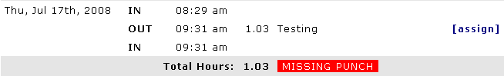
fig 2.0.1

No limit exists for the number of punches made in a single day. However, if the number of ‘In’ and ‘Start’ punches do not match the number of ‘Lunch’, ‘Out’, or ‘End’ punches, the system will generate a warning on the screen shown in figure 2.1 and in the weekly report until the problem is fixed. When the user clicks on the warning, they will see a page that will allow the fix to take place as discussed on page 12 of this manual.

Once the user has made the punch, they may remove the punch any time during the duration of the day. After the day has expired, the user will have to contact Salt Lake to have someone with a manager profile fix any punches made incorrectly.

In the top right hand corner, three links exist as follows:

The Week – This link shows the history for any given week (See Page 8)

Employees – This link shows the history for all employees (See Page 9)

Projects – This link shows the projects registered on the system (See Page 11)

** Only the users with a manager profile can see the last two links.

Last, a logout link exists in the top left-hand corner of the page.

The Week
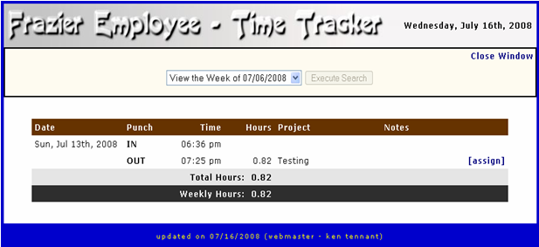
fig 2.1

On ‘The Week’ page, the user can see all of the punches made for a given week. The system will show only the weeks that exist for the user since they began using the system. When the user selects a specific week for viewing, the ‘Execute Search’ button becomes active and the user can click on it to show the activity of the selected week.

The ‘assign’ link shown in figure 3.0 will take the user to an ‘assignment’ page to update the project assigned to the recorded time. For further explanation of the page, go to page 12 of this manual.

Employees
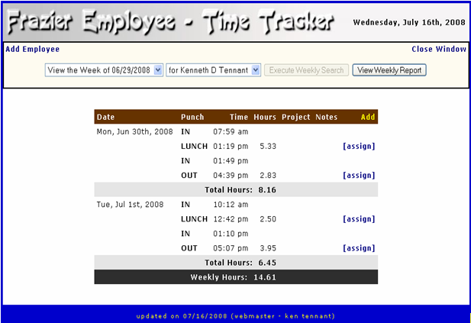
fig 2.2

The ‘Employees’ page shows the punches made by the employees of the system. Only the employees with management authority can see this page.

The ‘Add Employee’ link will take the user to a page listing all of the employees of the system where they can add and manage the users as discussed on page 13 of this manual.

Like ‘The Week’ page, the user can select a specific week and employee to view the punches made for the week. As shown in figure 4.0, the ‘Execute Weekly Search’ button will become active when the user changes the selection from the two list boxes.

The ‘View Weekly Report’ button will generate an Excel spreadsheet showing the activity done by any or all employees for a selected week and down load it to the local machine for further office use.

The yellow ‘add’ link will take the user to the ‘Add Entry’ page that is discussed on page 14 of this manual.

If the user has a missed punch for a specific day, this page will show a warning like shown and discussed on page 6 of this manual.

Projects
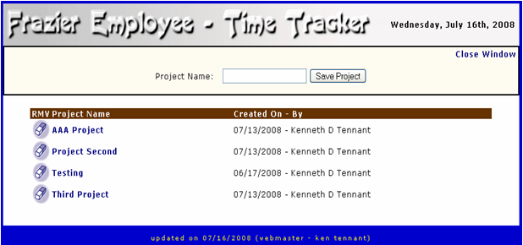
fig 2.3

The ‘Projects’ page allows the user with a manager profile to perform the following actions:

- Add a new project by typing in the name and clicking on the save button
- Change the project name by clicking on the name and filling out a dialogue box with the new name
- Remove a project

Missed Punch
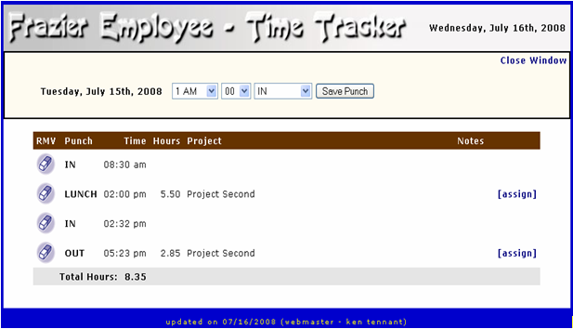
fig 3.0

The ‘Missed Punch’ screen will allow the user to do the following actions for a previously selected day:

- Save a new time punch
- Remove a time punch
- Update the project assignment for a punch

**Warning: When the user selects the ‘Absent’ type, a message box will appear for the user to fill out a reason for the absent.

Assignment
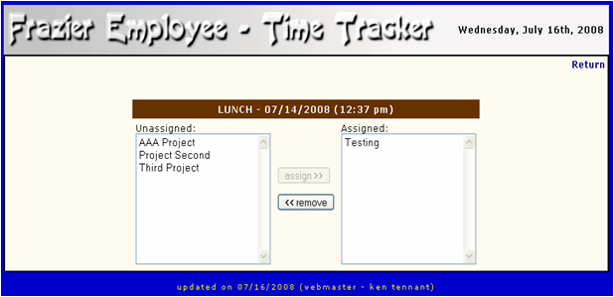
fig 4.0

The ‘Assignment’ page allows the user to update the project assigned to the allotted punch time. The user will see this page for only the ‘Lunch’ and ‘Out’ punch types. As shown in figure 3.1, the user selects the project name from the list and clicks on the active action button to assign and remove the project.

Because this page can appear from many of the other pages throughout the system, the page builds the ‘return’ link to send the user back to the page that they had come from.

Employee
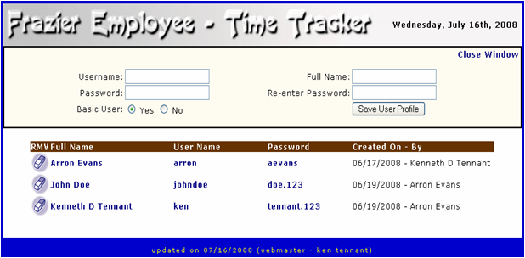
fig 5.0

The ‘Employee’ page gives a list of users registered on the system. The user can perform the following functions:

- Register a new profile
- Remove a profile
- Change the full name by clicking on it and filling out the dialogue box with the new information.
- Change the user name by clicking on it and filling out the dialogue box with the new information.
- Change the password by clicking on it and filling out the dialogue box with the new information.

Add Entry
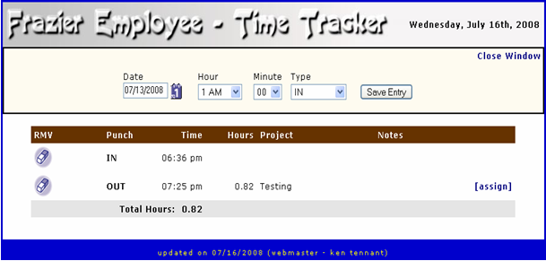
fig 6.0

The ‘Add Entry’ page will allow the user with a manager profile to perform the following actions:

1. Add a new punch for any given day.
2. Remove a punch for any given day.
3. Update the project assignment for any ‘Lunch’ or ‘Out’ punch.

**Warning: When the user selects the ‘Absent’ type, a message box will appear for the user to fill out a reason for the absent.

Conclusion

I hope that you have found this training manual helpful. Again, if you have any suggestions that will improve the use of this manual, please contact the author with the information stated at the beginning of this manual.

Future improvements to the system will have an affect on this manual. As they occur, this manual will be updated as quickly as possible for the best training in the use of this system.

